Assignment-24.2:

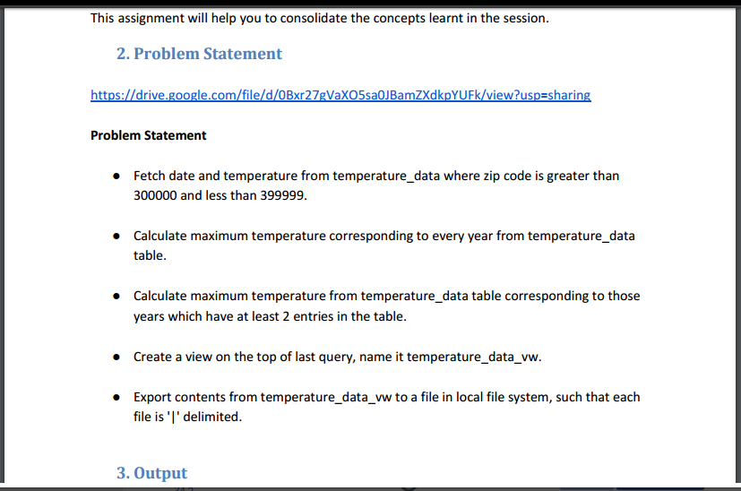

A database named custom is created and used. The temperature data is loaded. The contents of the table is displayed.

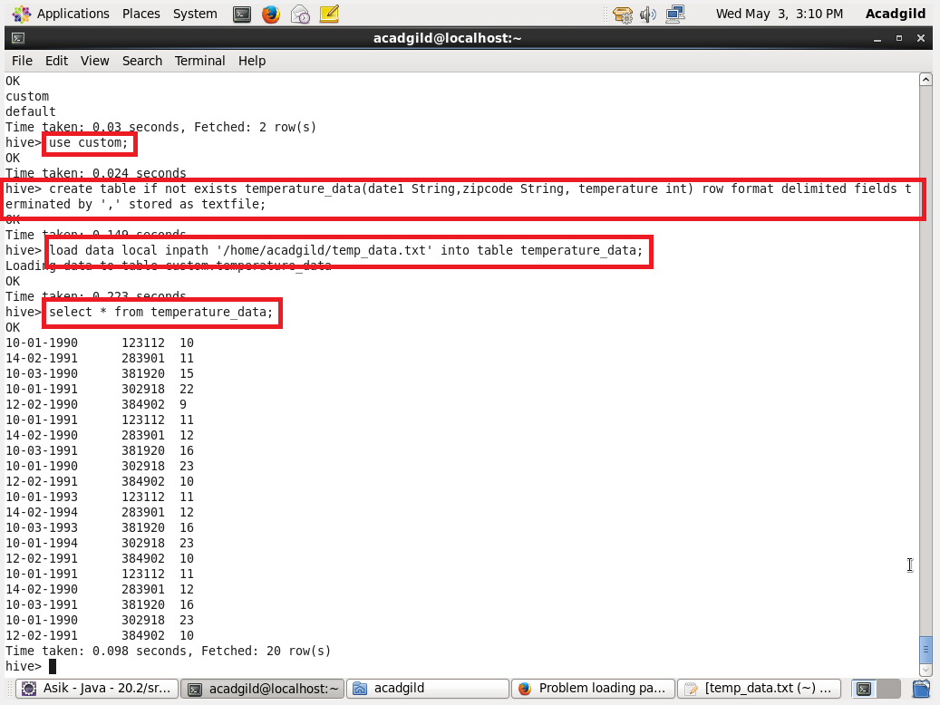

Question: Fetch date and temperature from temperature_data where zip code is greater than 300000 and less than 399999

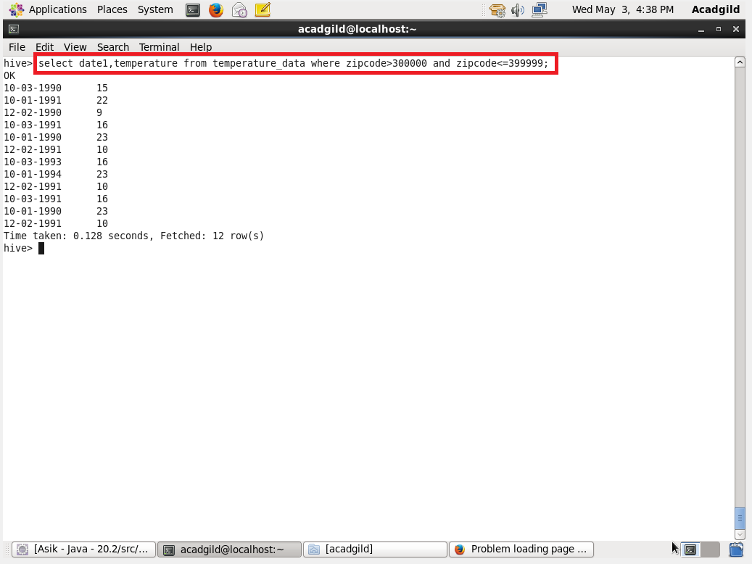

Question: Calculate maximum temperature corresponding to every year from temperature_data table.

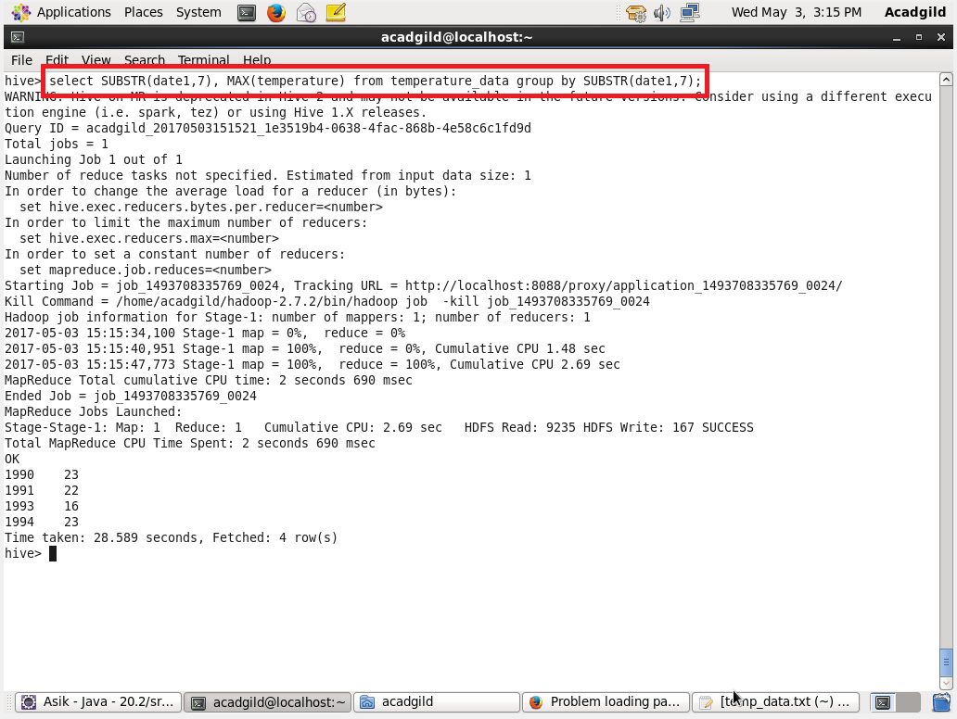

Question: Calculate maximum temperature from temperature_data table corresponding to those years which have at least 2 entries in the table.

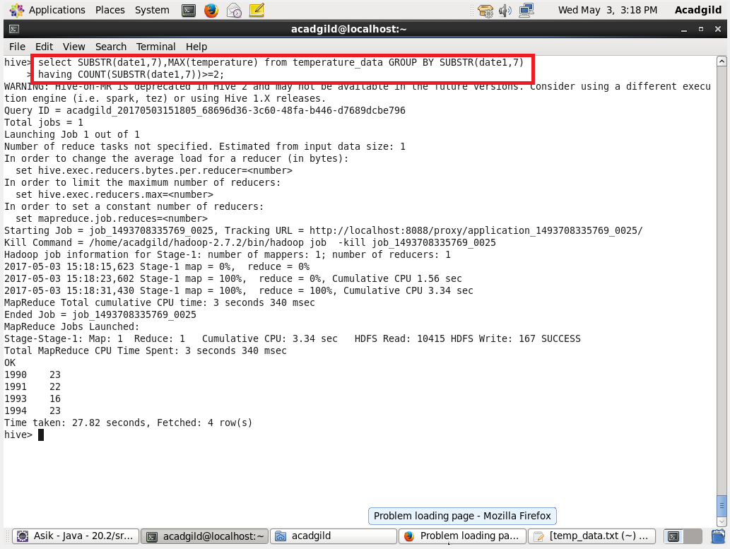

Question: Create a view on the top of last query, name it temperature_data_vw.

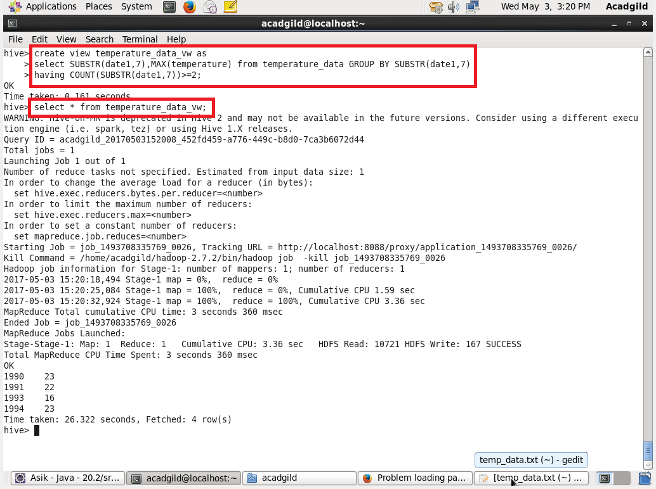

Question: Export contents from temperature_data_vw to a file in local file system, such that each file is '|' delimited.

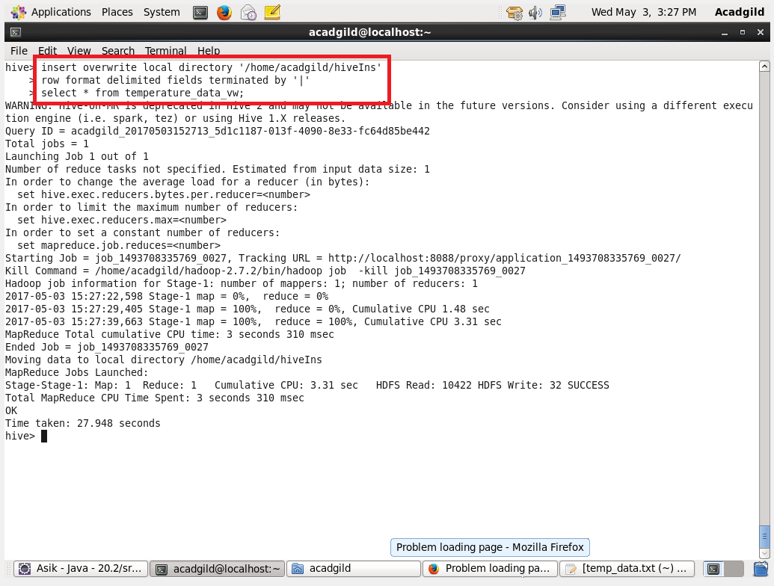

The Contents is exported into the local file system

